Brief Instructions for Completion of ALTA Best Practices Templates

- Add Law Firm’s name in the Company field of the Document Properties. When added here, the firm name will automatically populate the firm name wherever needed in the document. If the firm name changes at some future point, changing it here will update the name in all locations in the document. To access the Company field:
- In Word 2010 (pictured below), go to File/Info/Show All Properties
- In Word 2007, go to the Microsoft Office Button/Prepare/Properties. Select Advanced Properties in the Document Properties information drop-down menu. The Company field is located on the Summary tab.

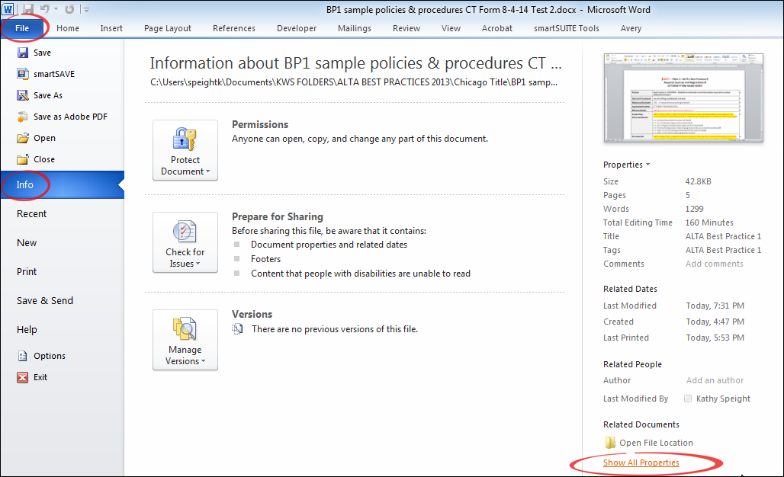

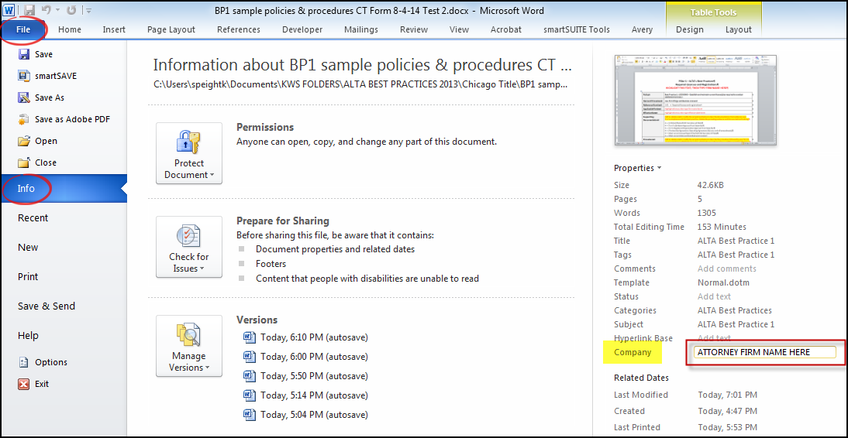

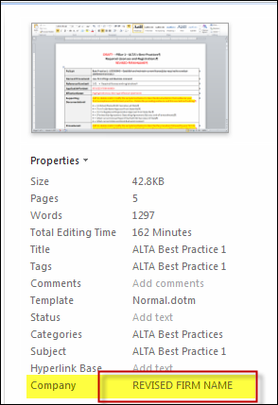

- Items that need to be completed in the Policies and Procedures sections (for which there is no sample text) are indicated by red font. Highlight the instructive text that appears in these areas and then type the information needed.

- Some sections in the Policies and Procedures include sample text to help you get started with completion of the section. An introductory explanatory statement in red font and highlighted in yellow precedes the sample language. This explanatory statement should be deleted before finalizing the document.

- No sample answers are provided in the Checklist sections as these are specific to each office and the information needed is self-explanatory.

- If you desire to change any red font to black font after you have completed all sections of the document, you can easily do so by choosing Select All and then selecting black as the font color. To do so, in Word 2010 and Word 2007, on the Home tab, go to the Editing group and choose Select and then Select All.

